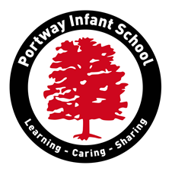

Summer 1 2026 EYFS Topic
Big Wide World
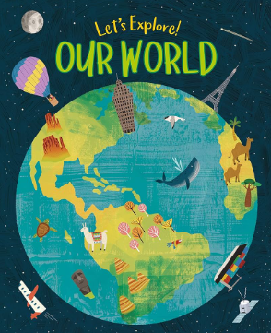

Please find below some information about your child’s learning this half term

This topic teaches children about the global community to which they belong and explores how living things, communities and climates differ around the world. We will also be learning about keeping plants alive and why they are important to our environment.

Through our topic work this term we will be learning …….
- Maths - We are teaching the children how to use a 10's frame and the notion of '5 and a bit' making numbers up to 10. We are also exploring part part whole methods, understanding that 7 is made up of 5 and 2.
- Phonics – We are starting our phase 4 phonics block. We still are revisiting phase 2 and 3 phonemes at the start of each lesson.
- Drawing club – Our drawing club book is ‘Oh Dear, Look What I Got!.
- PE – We are following our new PE scheme ‘Get set for PE’ and our focus will be on games where the children will learn physically skills and also team building and following different rules.
- PSHE (Personal Social Health Emotional) - Growing up great; we are learning about ‘Money matters’ and ‘being me’
- History - Past and present; we are learning about figures from the past and focusing on Charles Darwin.
- Science and Geography - Understanding the world; we are learning about climates, maps, animals from around the world and keeping plants alive.
- RE - People and communities; special places for worshipers
- Art, Music and Design Technology - Expressive arts and design; in Art we are going to be exploring painting for a purpose and referring back to our previous skill of colour mixing with powder paints. In music we are working our way through the Charanga block ‘Big Bear Funk!’
Forest School - Plants
- what plants to grow
- preparing vegetable beds
- planting seeds
- looing after plants
Ways to help at home
- Children must read their school reading book at least 4 times a week to a grown up at home. Books will only be changed when they have read their school book 3 or more times. Ensure you record this in their reading record.
- We recommend you watch the phonics videos at home that teachers send home each week. This will support their learning in school and help them to ‘keep up’ each week.
- We are learning to work with part part whole models. Here is a video link to support you at home: https://www.youtube.com/watch?v=tEJeeqvgopU
- We are learning about capacity. Now the weather is starting to get warmer this activity could be done outside or even in the bath. Fill containers, buckets, plastic bottles/cups using the language below. Have fun making your own potions!
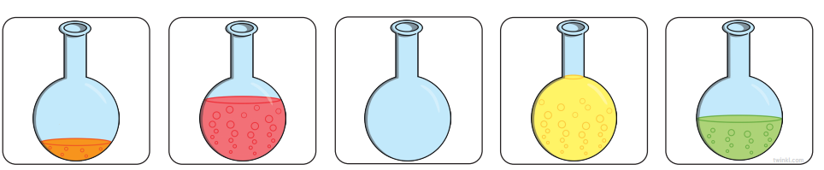
- Although number recognition to 20 is not essential in reception, we do expose the children to the teen numbers. In year 1 they need to learn numbers to 100, so getting in early would help them. Counting orally to 20 is essential.
- In science, we are learning about our different habitats, can you think of animals that live in our country and animals that live in other climates?
- In Geography, we are learning about hot and cold climates. Can you use google earth to find these different countries and where they are on the map?
- In PSHE we are learning about money and where we keep money to keep it safe. Can you go to the shop and let your child pay with money? How much is the item? Did you get any change? Talk about the value of the money.

- Have fun trying some of these things at home and don’t forget to share what you do on Dojo Portfolio so we can see!
Kind regards,
Foundation Team: Miss Brown and Miss Spensley

