Name : Date:______________
WALT- Identify a variety of flowering plants.
WILF- I can find and name these flowering plants around the school.
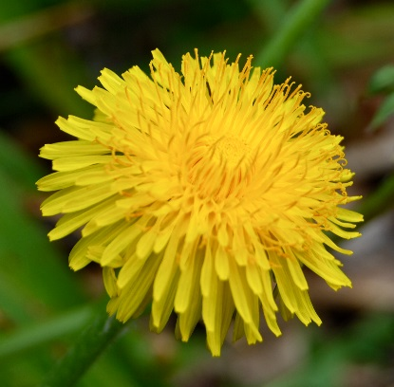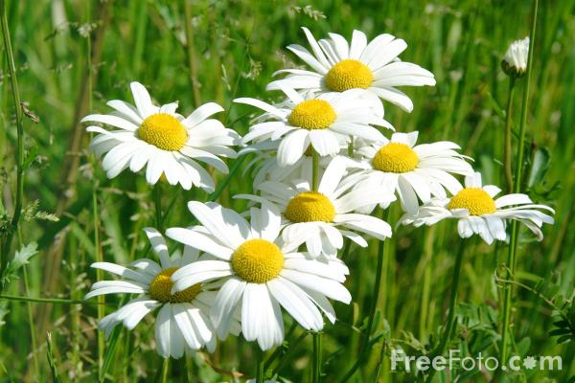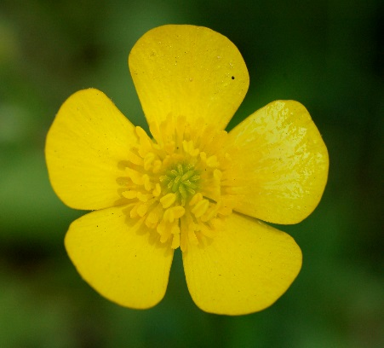
Dandelion Daisy Buttercup
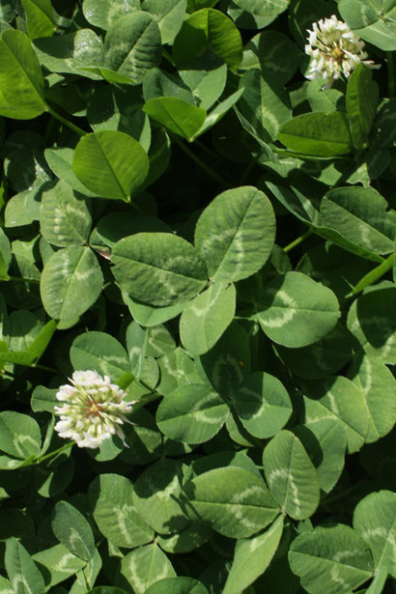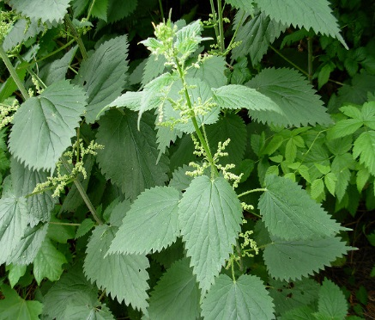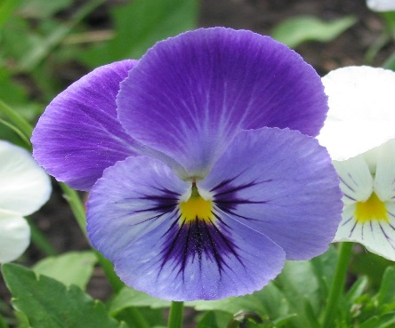
Clover Nettle Pansy
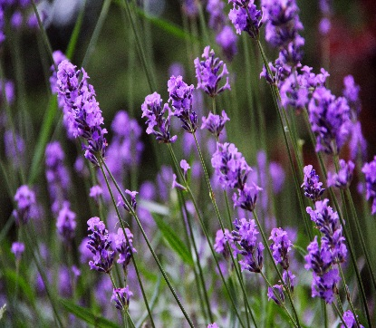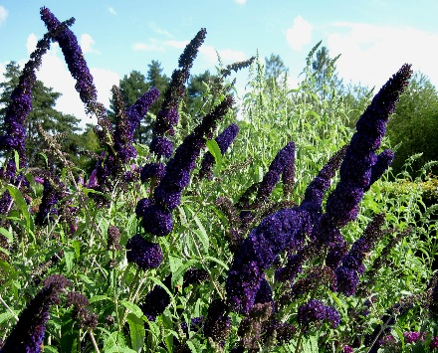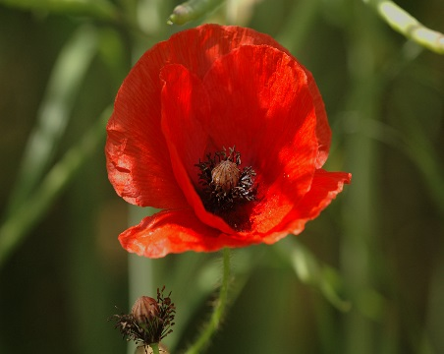
Lavender Buddleia Poppy

Name : Date:___________________
WALT- Identify and describe the structure of a common flowering plant.
WILF- I can draw a flowering plant and label the stem, leaf, root and flower.
Greater depth- I understand what the parts of the plant are for.
Challenge-

Flower- The part of the plant where are made.
Stem- The stem transports and nutrients around the plant.

Root- This part fixes the plant to the ground. It absorbs water and nutrients from the soil to help the plant to

Leaf- Where the plant makes food from .

Use these words to help you:
sunlight | water | seeds | grow

leaf
flower
stem
root

leaf
flower
stem
root

leaf
flower
stem
root

