Name____________________________ Date___________________________________
WALT – Design and make a castle with a drawbridge, choosing from a range of materials and parts.
WILF – I chose appropriate materials and parts so my drawbridge was strong and opened and closed.
Draw and label your castle with a drawbridge:
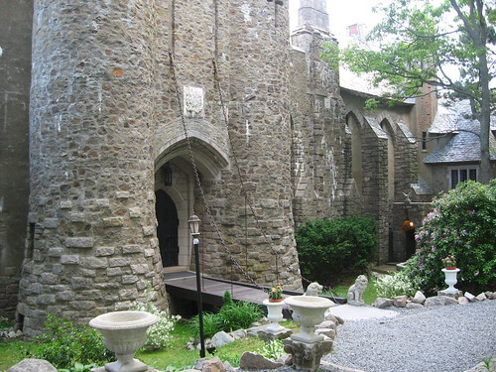

You can use –
a cereal box
scissors
string
dowelling
tape
E
Evaluate: Help words : strong opened closed

What worked well?

What could have worked better?

