Name____________________________ Date___________________________________
WALT – Explore how a structure can be made stronger, stiffer or more stable.
WILF- Using a range of construction kits, I can build a strong tower for Rapunzel that will keep her safe.
Draw and label your tower :
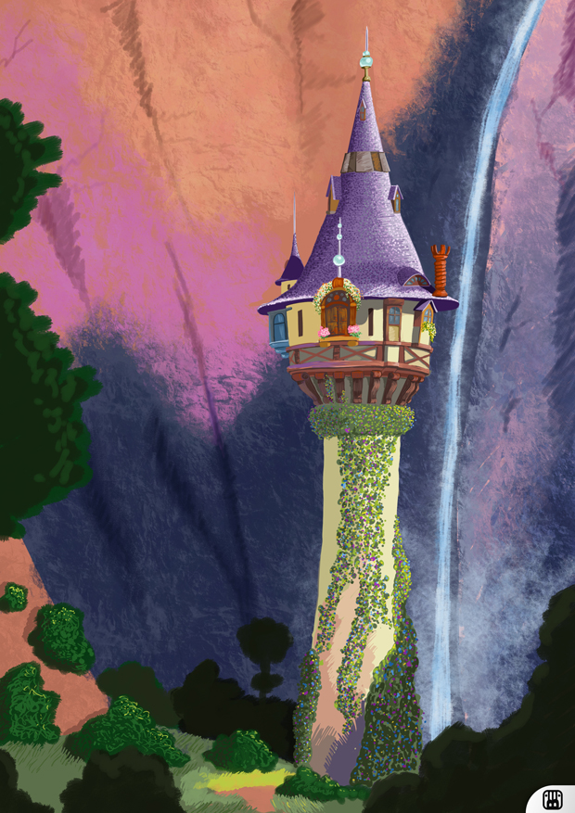

E
Evaluate: Help words : strong stable base

What worked well? Was it strong and stable?

What could have worked better?

