Numbers 1-10 visual and action

1 | 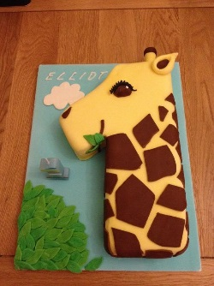 | Say 1 while…  Straight tall arm, hand munching leaves
2 | 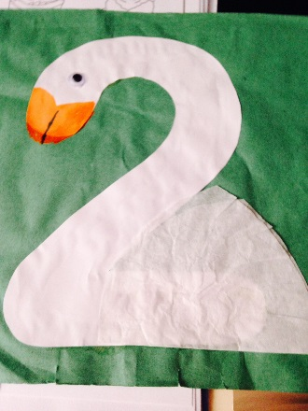 | Say 2 while …  Using right arm bend wrist over like the swans neck
3 | 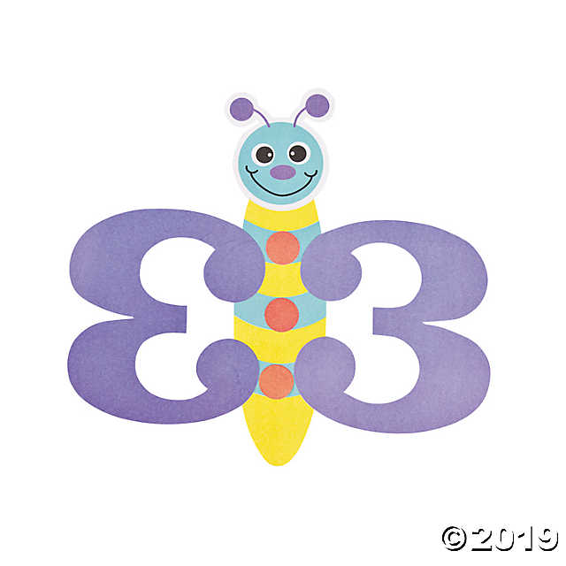 | Say 3 while…  Join thumbs and  flutter fingers
4 | 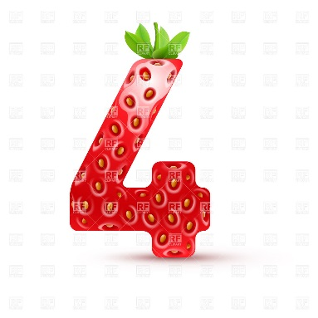 | Say fruity 4…  Makaton fruit sign, hand up to mouth eating a piece of fruit
5 | 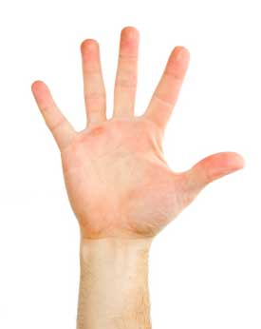 | Say high 5…  Children high 5 each other
6 | 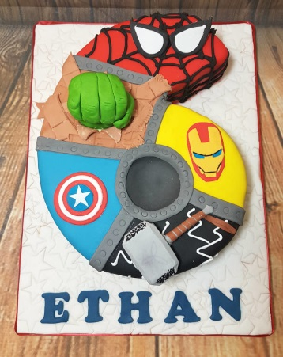 | Say super 6 …  Stretch arm up in a flying superhero position, pointing out that the 6 goes up
7 | 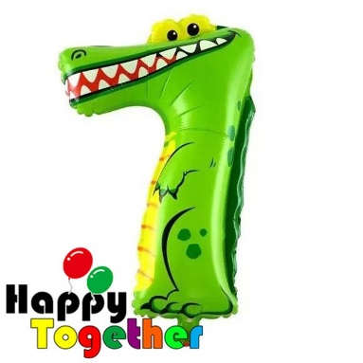 | Say snappy 7 …  Make a big mouth with arms clapping them together
8 | 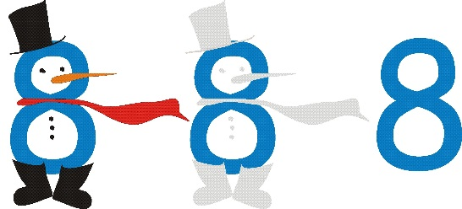 | Say snowman 8 ..  Use both hands to outline the snowman’s body
9 | 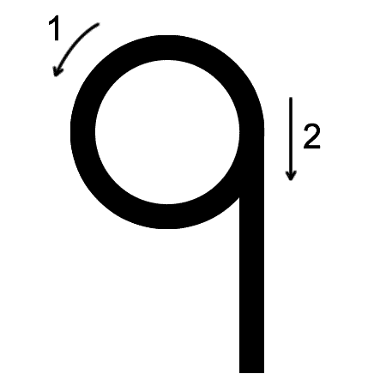 | Say naughty 9…  Wagg a naughty finger, with a cross face and draw the 9, pointing out the 9 goes down.
10 | 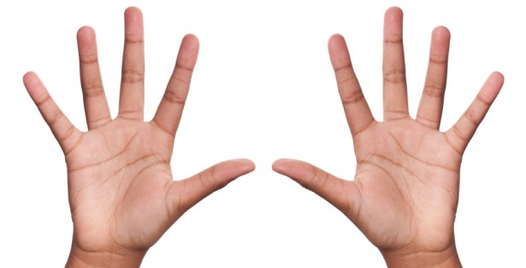 | Say high 10..  Children high 10 each other

